ЛАБОРАТОРНА РОБОТА №7

ТЕМА: РЕСУРСИ В WPF

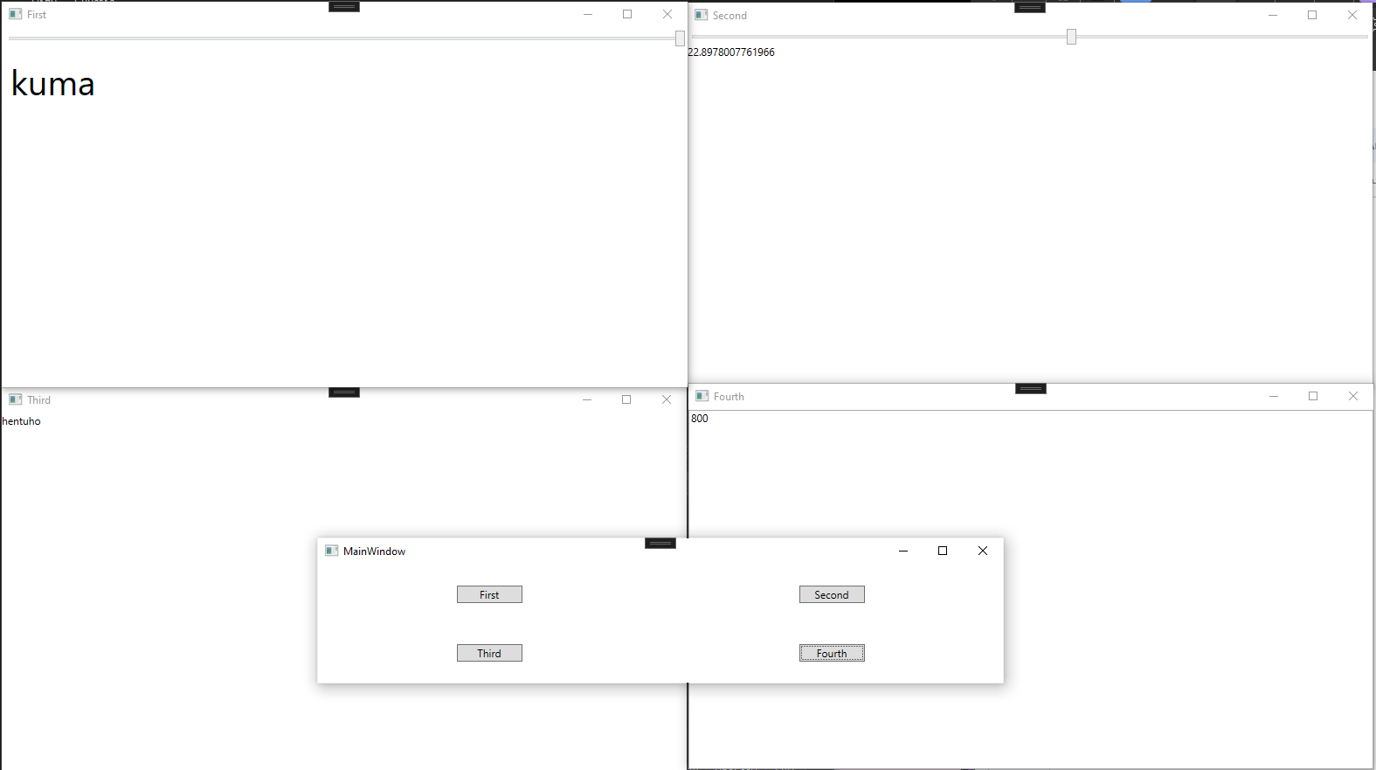

| MainWindow.xaml |
| --- |
| <Window x:Class="WpfApp6.MainWindow"  xmlns="http://schemas.microsoft.com/winfx/2006/xaml/presentation"  xmlns:x="http://schemas.microsoft.com/winfx/2006/xaml"  xmlns:d="http://schemas.microsoft.com/expression/blend/2008"  xmlns:mc="http://schemas.openxmlformats.org/markup-compatibility/2006"  xmlns:local="clr-namespace:WpfApp6"  mc:Ignorable="d"  Title="MainWindow" Height="450" Width="800">  <Grid>  <Grid.ColumnDefinitions>  <ColumnDefinition Width="*"/>  <ColumnDefinition Width="*"/>  </Grid.ColumnDefinitions>  <Grid.RowDefinitions>  <RowDefinition Height="*"/>  <RowDefinition Height="*"/>  </Grid.RowDefinitions>  <Button Grid.Row="0" Grid.Column="0" Content="First" HorizontalAlignment="Center" VerticalAlignment="Center" Width="75" Click="Click"/>  <Button Grid.Row="0" Grid.Column="1" Content="Second" HorizontalAlignment="Center" VerticalAlignment="Center" Width="75" Click="Click"/>  <Button Grid.Row="1" Grid.Column="0" Content="Third" HorizontalAlignment="Center" VerticalAlignment="Center" Width="75" Click="Click"/>  <Button Grid.Row="1" Grid.Column="1" Content="Fourth" HorizontalAlignment="Center" VerticalAlignment="Center" Width="75" Click="Click"/>  </Grid>  </Window> |

| MainWindow.xaml.cs |
| --- |
| using System;  using System.Collections.Generic;  using System.Linq;  using System.Text;  using System.Threading.Tasks;  using System.Windows;  using System.Windows.Controls;  using System.Windows.Data;  using System.Windows.Documents;  using System.Windows.Input;  using System.Windows.Media;  using System.Windows.Media.Imaging;  using System.Windows.Navigation;  using System.Windows.Shapes;  namespace WpfApp6  {  /// <summary>  /// Логика взаимодействия для MainWindow.xaml  /// </summary>  public partial class MainWindow : Window  {  public MainWindow()  {  InitializeComponent();  }  private void Click(object sender, RoutedEventArgs e)  {  Button btn = (Button)sender;  Win1 win1 = new Win1();  Win2 win2 = new Win2();  Win3 win3 = new Win3();  Win4 win4 = new Win4();  switch (btn.Content.ToString())  {  case "First":  win1.Title = "First";  win1.Show();  break;  case "Second":  win2.Title = "Second";  win2.Show();  break;  case "Third":  win3.Title = "Third";  win3.Show();  break;  case "Fourth":  win4.Title = "Fourth";  win4.Show();  break;  }  }  }  } |

| Win1.xaml |
| --- |
| <Window x:Class="WpfApp6.Win1"  xmlns="http://schemas.microsoft.com/winfx/2006/xaml/presentation"  xmlns:x="http://schemas.microsoft.com/winfx/2006/xaml"  xmlns:d="http://schemas.microsoft.com/expression/blend/2008"  xmlns:mc="http://schemas.openxmlformats.org/markup-compatibility/2006"  xmlns:local="clr-namespace:WpfApp6"  mc:Ignorable="d"  Title="Win1" Height="450" Width="800">  <Grid>  <StackPanel>  <Slider Name="Slider" Margin="3" Minimum="1" Maximum="40"/>  <TextBlock Name="TextBlock" Margin="10" Text="kuma" FontSize="{Binding ElementName=Slider, Path=Value}"/>  </StackPanel>  </Grid>  </Window> |

| Win2.xaml |
| --- |
| <Window x:Class="WpfApp6.Win2"  xmlns="http://schemas.microsoft.com/winfx/2006/xaml/presentation"  xmlns:x="http://schemas.microsoft.com/winfx/2006/xaml"  xmlns:d="http://schemas.microsoft.com/expression/blend/2008"  xmlns:mc="http://schemas.openxmlformats.org/markup-compatibility/2006"  xmlns:local="clr-namespace:WpfApp6"  mc:Ignorable="d"  Title="Win2" Height="450" Width="800">  <Grid>  <StackPanel>  <Slider Name="Slider" Minimum="1" Maximum="40" Value="10"/>  <TextBlock Name="TextBlock" Text="{Binding ElementName=Slider, Path=Value,  Mode=TwoWay, UpdateSourceTrigger=PropertyChanged}"/>  </StackPanel>  </Grid>  </Window> |

| Win3.xaml |
| --- |
| <Window x:Class="WpfApp6.Win3"  xmlns="http://schemas.microsoft.com/winfx/2006/xaml/presentation"  xmlns:x="http://schemas.microsoft.com/winfx/2006/xaml"  xmlns:d="http://schemas.microsoft.com/expression/blend/2008"  xmlns:mc="http://schemas.openxmlformats.org/markup-compatibility/2006"  xmlns:local="clr-namespace:WpfApp6"  mc:Ignorable="d"  Title="Win3" Height="450" Width="800">  <Window.Resources>  <local:kuma x:Key="Kuma" Name="hentuho" Age="18" Address="funeral" />  </Window.Resources>  <StackPanel DataContext="{StaticResource Kuma}">  <TextBlock Text="{Binding Name}"/>  </StackPanel>  </Window> |

| Win4.xaml |
| --- |
| <Window x:Class="WpfApp6.Win4"  xmlns="http://schemas.microsoft.com/winfx/2006/xaml/presentation"  xmlns:x="http://schemas.microsoft.com/winfx/2006/xaml"  xmlns:d="http://schemas.microsoft.com/expression/blend/2008"  xmlns:mc="http://schemas.openxmlformats.org/markup-compatibility/2006"  xmlns:local="clr-namespace:WpfApp6"  mc:Ignorable="d"  Title="Win4" Height="450" Width="800">  <Window.Resources>  <local:PositivePriceRule x:Key="PositivePriceRule" Max="999.99"/>  </Window.Resources>  <Grid>  <TextBox>  <TextBox.Text>  <Binding Path="UnitCost" Mode="TwoWay">  <Binding.ValidationRules>  <local:PositivePriceRule Max="999.99"/>  </Binding.ValidationRules>  </Binding>  </TextBox.Text>  </TextBox>  </Grid>  </Window> |

| Class1.cs |
| --- |
| using System;  using System.Collections.Generic;  using System.Diagnostics.Contracts;  using System.Linq;  using System.Text;  using System.Threading.Tasks;  using System.Windows.Controls;  using System.Globalization;  namespace WpfApp6  {  public class kuma  {  public string Name { get; set; }  public short Age { get; set; }  public string Address { get; set; }  public kuma()  {  Name = "";  Age = 0;  Address = "";  }  }  public class PositivePriceRule : ValidationRule  {  private decimal min = 0;  private decimal max = Decimal.MaxValue;  public decimal Min  {  get { return min; }  set { min = value; }  }  public decimal Max  {  get { return max; }  set { max = value; }  }  public override ValidationResult Validate(object value, System.Globalization.CultureInfo cultureInfo)  {  decimal price = 0;  try  {  price = Decimal.Parse((string)value, NumberStyles.Any, cultureInfo);  }  catch  {  return new ValidationResult(false, "Неприпустимі символи");  }  if ((price < Min) || (price > Max))  {  return new ValidationResult(false, "Поза діапазоном");  }  else  {  return new ValidationResult(true, null);  }  }  }  } |